Bird.io Documentation

ILYAAS DAVIDS

CONTENTS

Introduction ………………………………………………………………………………………………… Pg 2

App Overview ……………………………………………………………………………………………. Pg 3-4

Requirements …………………………………………………………………………………………… Pg 4-5

UI Mockups ………………………………………………………………………………………………. Pg 6-13

User Data Requirements ………………………………………………………………………… Pg 14-15

Project Plan …………………………………………………………………………………………………. Pg 16

Conclusion ……………………………………………………………………………………………… Pg 16-17

References …………………………………………………………………………………………………… Pg 17

Introduction

Often, we don’t realize that technology is evolving rapidly making it difficult to keep up with trends. Looking back at how far we’ve come it is difficult to predict what the future holds. Will our cars be able to fly? Will robots take over and enslave the human race? It’s possible but highly unlikely. Simple pieces of technology such as mobile applications have changed drastically over the past decade. A prime example would be the “Snake Game” that we all love and know. It started out as a simple 2D game that grows the player’s snake pixel by pixel after eating another level up pixel. In today’s world we are able to play complex video games which can be run at 60 FPS (frames per second, which is basically HD) such as Call Of Duty, FIFA and Minecraft on our mobile devices which we previously thought was only possibly to enjoy on gaming consoles. With the tools and technologies available today it has become drastically easier to create mobile applications. So much so that we have the ability to create applications that serve almost any purpose the developer would like it to.

Bird watching is an art that has been practiced for decades and allows bird watchers to discover new species of these feathery creatures and study the behavior and migrating patterns as well. It is important that bird watchers document all the important traits of these bird so it can be used for further research however it can be troubling scribbling down all those traits while keeping extremely still to avoid scaring the birds away. An application that could simplify these documentation processes would greatly improve the efficiency of bird watchers as well as adding extra features that would guide them navigationally such as gps tracking, image capturing and path capturing (which would fall under the gps feature). The important information can be stored in a database that can be accessed on the application by other bird watchers which increases the rate that information can be shared globally. All these features mentioned is just the tip of the iceberg and can be implemented easily using the right technology tools.

App Overview

The main purpose of the application is to assist birdwatchers with finding, documenting, and sharing information with other birdwatchers. To connect the user to the application an account is required. User details can be captured through a sign-up page and stored in a database. This way when the user logs in, all their progress is saved. This feature also gives way to a “Profile Page” within the application which can hold the statistics of the user such as: Distance walked, Birds spotted, New Species Discovered and Weekly goals or objectives. When the user logs in they have full access to all features of the application including the GPS tracking system, social features and the database of previously found species. They also have access to bird documentation tools such as the image capture and notebook which comes in handy when wanting to quickly document a species. The GPS tracking system allows the user to track birds within a certain radius and provides the user with the quickest route to the desired bird. Users can also see themselves on the GPS system which is quite accurate and gives the user a fair representation of how far or near they are to a bird species.

App Name: Bird.io

Icon Design:

Innovative Features:

* A User Statistics Page that displays all the user information regarding how they have progressed such as, number of species discovered, distance walked, most time spent in area, images capture count etc.
* Blog Post that can be added to the home page, other users can see blog posts.
* Users can search the database for a specific bird which will display all the information about the desired bird (they can also add birds to the database).
* Users can use the “Bird Comparison” feature to compare different species side by side displaying all the information and images of two desired birds.
* Users can capture images of birds

Requirements

* When the user runs the application for the first time, they must be able to register themselves for an account. This page should capture the user details which will be stored in a database and used to login after they have registered.
* As mentioned previously, the user will need to enter their login credentials they created on the previous “Register” page to access the application. Only authenticated users will be allowed access.
* Apart from the main features the application should have a separate page dedicated to altering the settings of the application. The user should have the option to change from metric to imperial which will contribute to the universal aspect of the application.
* The user should be able to make use of the GPS system which needs to be nested within the application however we will make use of an API to get the required information from a server.
* The application should prompt the user for a distance which will act as a diameter (and filter) to a radius size. Once entered the application should be able to display all the bird hotspots within the radius.
* The user should also be able to see themselves on the map. This feature gives way to personalize the application even further by allowing the user to see themselves via a type of avatar (which could be done using an image).
* When the user taps on a desired hotspot to navigate to, the GPS system should visually calculate the best possible route to the bird hotspot. The app should also provide the user with more than one route option to choose from increasing the conveniency of the application
* Once at the desired location the application should provide the user with a feature that allows the user to document and save their bird at the exact hotspot as well as view the information that they have entered on the app and GPS map.
* All relevant information should be stored in an online database (most likely Firebase will be suitable).
* Apart from the observations that will be recorded by the user, the application should also be able to allow the user to document short notes that can be stored and view in a separate “notes” page that will hold the date, current location and note that the user has entered.
* The “Profile” page is an extra feature that will allow users to view their profile statistics as well as change their avatar (which can be seen on the map).
* When the user detours off the calculated route the app should be able to recalculate the route according to the user’s movement (this feature is included in most GPS applications).
* The app requires Camera access to provide the user the luxury of capturing images from their phone (Storing the images with the observation would be great feature but would need some planning due to pixel resolution and the loading of the images each time the application runs).

User Interface Mockups

1. User Login/Sign up Page

1. Home page

1. User profile Page

1. GPS page

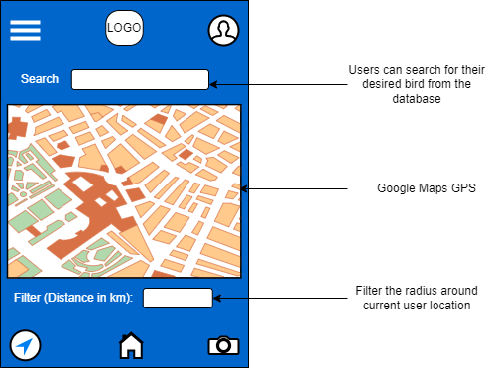

1. Camera feature page

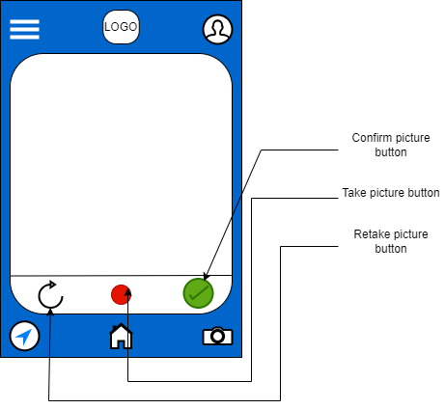

1. Burger Navigation

1. Notes page

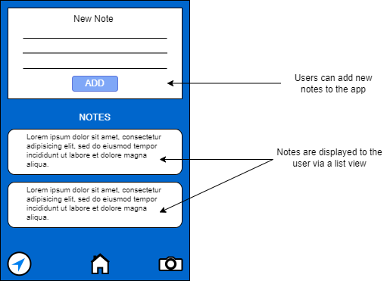

1. Bird Comparison page

Required Application Data

|  |  |
| --- | --- |
| Data Name | Data Type |
| Username | String |
| Password | String |
| Email | String |

1). User Registration Page

2). User Login Page

|  |  |
| --- | --- |
| Data Name | Data Type |
| LoginUsername | String |
| LoginPassword | String |

3). GPS/Observation Page

|  |  |
| --- | --- |
| Data Name | Data Type |
| userSelectedDistance | Int |
| birdName | String |
| birdColour | String |
| birdType | String |
| birdExtraNotes | String |
| birdFlightType | Boolean |

4). Bird Comparison Page

|  |  |
| --- | --- |
| Data Name | Data Type |
| birdOneName | String |
| birdTwoName | String |

5). Extra Notes Page

|  |  |
| --- | --- |
| Data Name | Data Type |
| notesDate | DateTime |
| note | String |
| noteLocation | String |

6). Profile Page

|  |  |
| --- | --- |
| Data Name | Data Type |
| userProfileImage | Image |
| userGoal | Int |
| userNameChange | String |

Project Plan Gantt Chart

Conclusion

Any project's success via diligence, cooperation, and commitment is its ultimate goal. All of the specifications that were required during the planning stage should be satisfied by the finished product. As developers, we should make an effort to not only comply with these standards but also go above and beyond what is required in order to please and benefit both parties. Additionally, it is crucial that we plan ahead because we will almost certainly need to refer to project plan documents when we encounter challenges. The majority of developers have trouble communicating with one another, which would make getting over difficulties much more difficult. Through regular stand-ups, when employees can share their work, challenges, and solutions with other colleagues, it is crucial to develop good communication.

In conclusion, there shouldn't be any concern about the project failing as long as we work steadily, complete all the deliverables, and hit each milestone. The only reason this project wouldn't be successful is if enough effort and motivation were put into it.

Reference List

Applications

1. Birda:<https://play.google.com/store/apps/details?id=com.chirpbirding.birda>
2. eBird:<https://play.google.com/store/apps/details?id=edu.cornell.birds.ebird>
3. GoBird:<https://play.google.com/store/apps/details?id=edu.cornell.birds.ebird>